* Git configure

git config --global user.email <email id>

git config --global user.name "Your Name"

We configured git with git hub with user name and email

For communication between git and github

We have to create account in github from online website.

$ git config --global user.name bshanu

$ git config --global user.email shanu461280@gmail.com

$ pwd

/data/data/com.termux/files/home/project

$ ls

file1.txt file2.txt file3.txt

$ cat file1.txt

This is the first file of Project ########## File1.txt ########### This project uses the different languages for build the CODE.

$ cat file2.txt

This is the file2.txt file

This file contians Only .html files

$ cat file3.txt

This is the file3.txt file

This file contaims only C# Files

* First we have initialize the git by using command

$ git init

$ git init

hint: Using 'master' as the name for the initial branch. This default branch name

hint: is subject to change. To configure the initial branch name to use in all

hint: of your new repositories, which will suppress this warning, call:

hint: hint: git config --global init.defaultBranch <name>

hint: hint: Names commonly chosen instead of 'master' are 'main', 'trunk' and

hint: 'development'. The just-created branch can be renamed via this command:

hint:

hint: git branch -m <name>

Initialized empty Git repository in /data/data/com.termux/files/home/project1/.git/

* Tracking and Un tracking Files Identification

By using the command as

$ git status

On branch master

No commits yet

Untracked files: (use "git add <file>..." to include in what will be committed) file1.txt

nothing added to commit but untracked files present (use "git add" to track)

* Now adding above files from Working area to Staging Area by using command

$ git < file name > or

$ git add . (All files at a time)

$ git add .

Then check the status of git

$ git status

On branch master

No commits yet

Changes to be committed: (use "git rm --cached <file>..." to unstage)

new file: file1.txt

$ git status

On branch master

No commits yet

Changes to be committed: (use "git rm --cached <file>..." to unstage)

new file: file1.txt

Untracked files:

(use "git add <file>..." to include in what will be committed)

file2.txt

file3.txt

Now add file.txt and file.txt files all at a time by using add . Command

$ git status

On branch master

No commits yet

Changes to be committed: (use "git rm --cached <file>..." to unstage)

new file: file1.txt

new file: file2.txt

new file: file3.txt

GIT

Git is looking up all tracked and untracked files

GLOBAL INFORMATION TRACKER

Untracked Files

Tracked Files

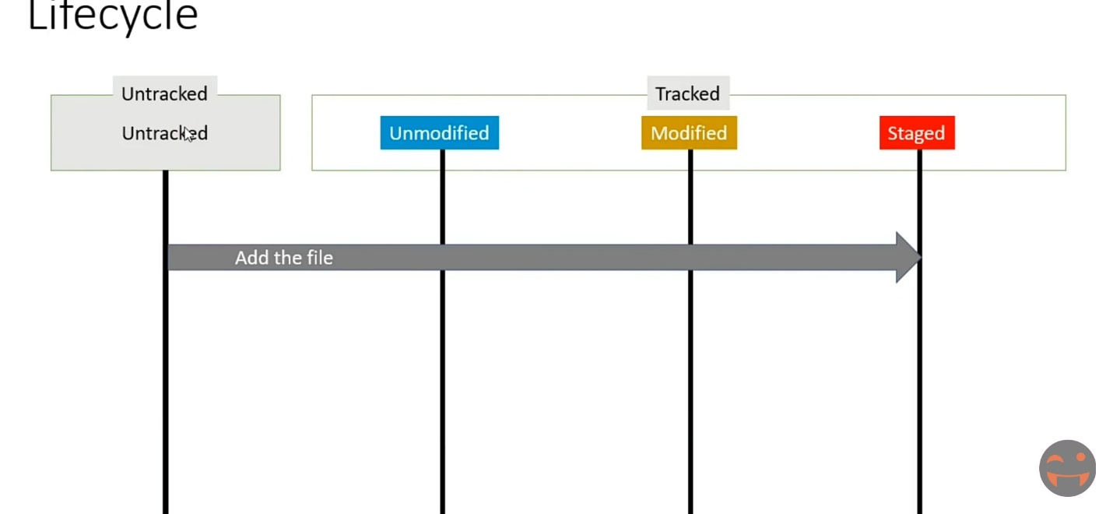

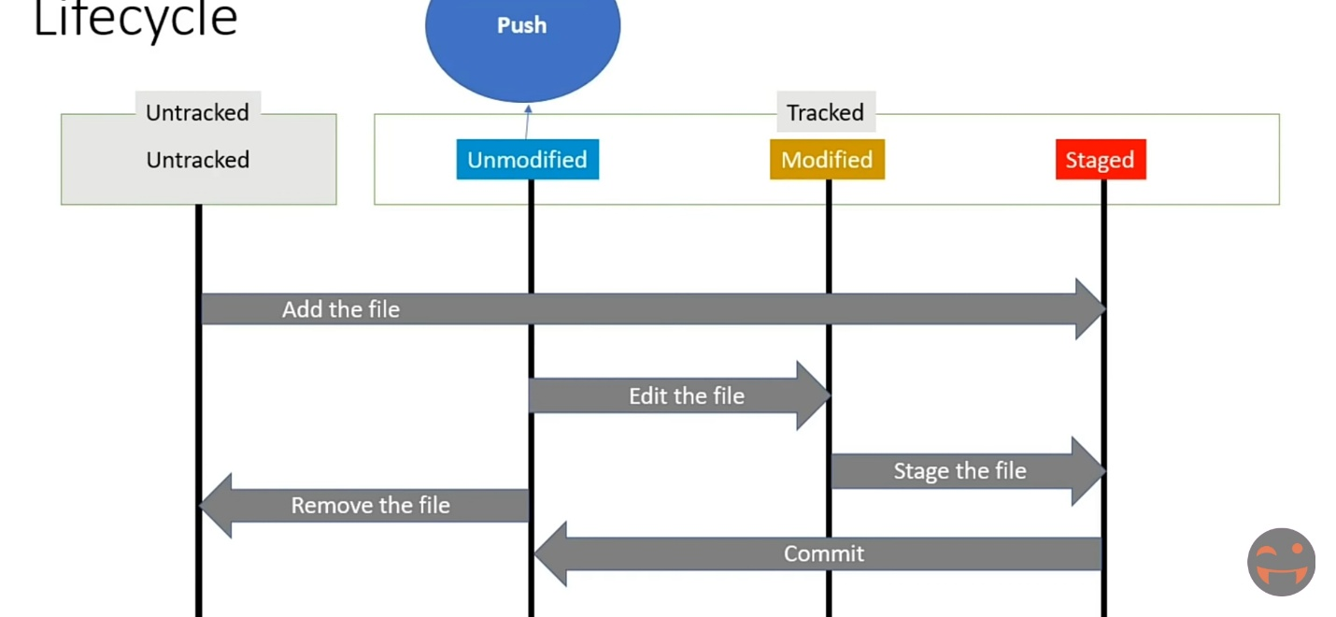

* Now commit the files. I.e moving staging area to repository
* By as follows

For that first check the status of git once

$ git status On branch master

No commits yet

Changes to be committed:

(use "git rm --cached <file>..." to unstage)

new file: file1.txt

new file: file2.txt

new file: file3.txt

Now commit as follows

$ git commit -m "This is the first commit of all files f1,f2 and f3"

[master (root-commit) f505ee2] This is the first commit of all files f1,f2 and f3

3 files changed, 7 insertions(+)

create mode 100644 file1.txt

create mode 100644 file2.txt

create mode 100644 file3.txt

We create an account with github

Clone url is

<https://github.com/Bshanu/Mobile-Rep.git>